**Big Mountain Ski Resort Data Science Report**

**Written by Dawn Betzel**

Big Mountain Ski Resort in Montana recently installed a chair lift to help increase distribution of visitors across the mountain. Buying and installing the chair lift increased operating costs by about $1.5 million this season. The executives at Big Mountain Ski Resort decided to take a look at their pricing strategy. They wanted to determine if their pricing strategy of charging a premium over the average price of other resorts in its market segment was the best approach. To offset the additional operating costs the executives are willing to consider different pricing, cutting costs, or adding new features.

The executive team suggested four scenarios that they feel would validate the ticket cost. The scenarios include the permanent closure of up to ten of the least used runs and keeping the ticket price structure the same. Increase ticket prices to cover the additional operating cost or increase the price and add additional features. The additional features being evaluated are increasing the vertical drop by adding a run to a point 150 feet below the current longest trail including the installation of an additional chair lift to bring skiers back up. Increase the vertical drop as above but include two acres of snow making. Lastly increase the longest run by two tenths of a mile to boast a run of three and a half miles in length, which would require additional snow making coverage of four acres.

The first scenario consisting of closing up to ten of the least used runs. The analysis shows that you can close up to five runs without significant change in ticket price with a relative drop of about $500,000 in revenue, any further drop of runs would result in much lower ticket prices and almost three times the $500,000 in loss of revenue. See figure 1 below.

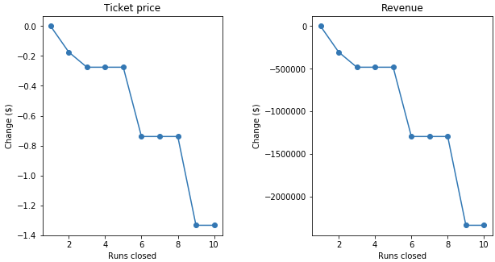

Figure 1 Analysis of closing runs vs revenue

The second scenario would add a run, increase the vertical drop by one 150 feet would support a price increase of $8.67 and would increase the revenue to around $15 million.

The third scenario is the same as the second scenario but added two acres of snow making and would support a price increase of $10.59 per ticket and would generate and additional $3.5 million in revenue for a total of $18.5 million.

The fourth and final scenario increased the longest run by 0.2 miles and guaranteeing snow coverage by the addition of 4 acres of snow making could not recommend a change in ticket price.

Both scenario two and scenario three seem like good possibilities. Either will increase ticket price and both with generate more revenue. Once we are able to add in the cost for the added features into our model, we should run again to see if it is cost effective to make the changes in scenario three or if it would be better to use scenario two.